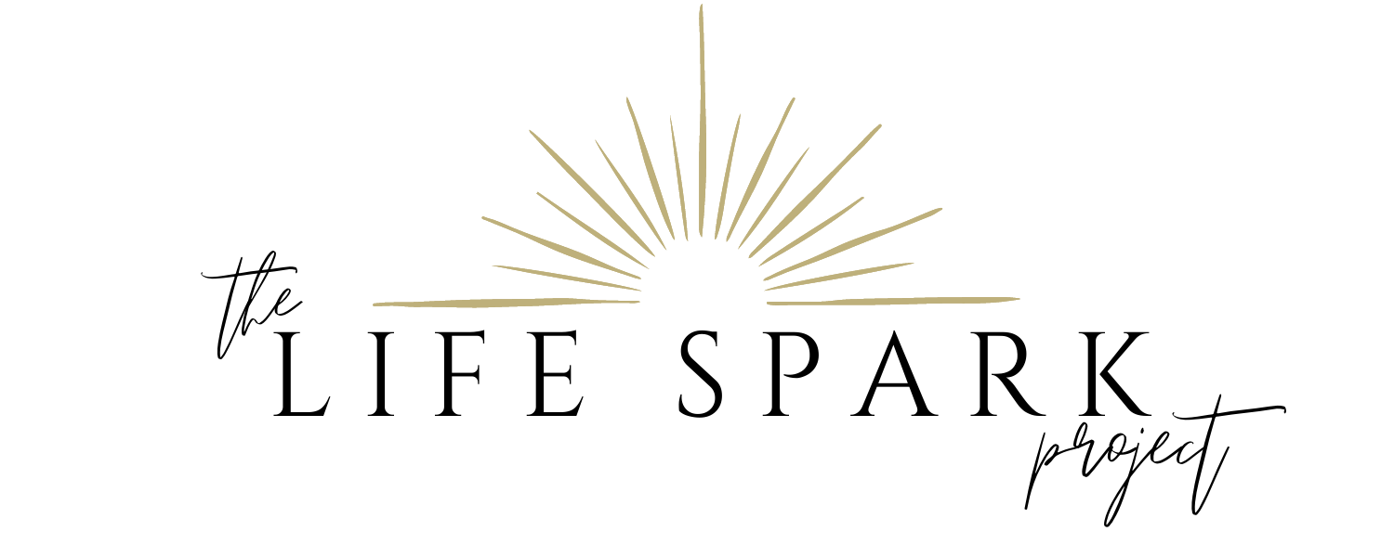

Birth Plan

We are very excited to be working with (OB or Midwife’s Name) and (Name of Hospital) Hospital staff as we welcome our first child into the world. We look forward to sharing this joyous occasion with you.

Our goal is a totally natural birth and we appreciate all the support and encouragement you can provide. We believe (Name)’s active participation as the birth coach, along with the care of our Doula, (Doula’s Name), will enable (Birthing Mother’s name) to achieve a natural birth. Our top priority for (Birthing Mother’s Name) and the baby to baby. Assuming mother and baby are fine, these are our preferences:

To experience a drug-free labor and birth: We are fully aware of our options and request that the staff not ask (Birthing Mother’s name) pain scale or offer pain medication.

To avoid the use of the following medical interventions:
- We do not consent to artificially rupturing membranes or artificial augmentation of labor (including pitocin during labor). Please discuss these interventions with us if they become necessary.
- We do not consent to an episiotomy. Please discuss this intervention with us if one is necessary.
- Measures that inhibit mobility (IV – (Birthing Mother’s name) is okay with a saline lock, intermittent EFM only please).

We would appreciate:
- If staffing allows, a nurse is passionate about natural childbirth.
- The ability to use natural labor techniques to start, speed, or manage labor.
- The ability to eat and drink during labor.
- Encouragement during delivery to use instinctive, natural pushing techniques and positions, free of time limitations.

After the birth of our baby:
- Immediate skin to skin contact for a minimum of 1 hour to promote breastfeeding and bonding (Birthing Mother’s name) and baby covered with blankets if necessary for warmth.
- (Name) would like to do skin to skin. Please help facilitate skin to skin after (Breastfeeding Mother and Baby have nursed).
- Delay clamping of the umbilical cord until pulsating has stopped. Parent’s would like to feel the cord before it is clamped.
- Newborn procedures (baby assessment, heart rate, temperature, eye ointment, Vitamin K shot, measurements, etc.) to be on (Birthing Mother’s name) chest. We would like to give our baby his or her first bath no earlier than 12 hours after the baby is born.
- We chose not to circumcise if our child is a boy.

We understand that no natural event can be scripted and that unforeseen circumstances occur. The health of (Birthing Mother’s name) and baby are of utmost importance. We have full confidence in our birth team and their professional opinions. Should a situation arise that requires deviation from our plan we know our birth team will discuss the risks and benefits of any procedure prior to taking action. Thank you for considering and honoring our desires and supporting us in having a natural childbirth.

